Swainswick Primary 2020-21
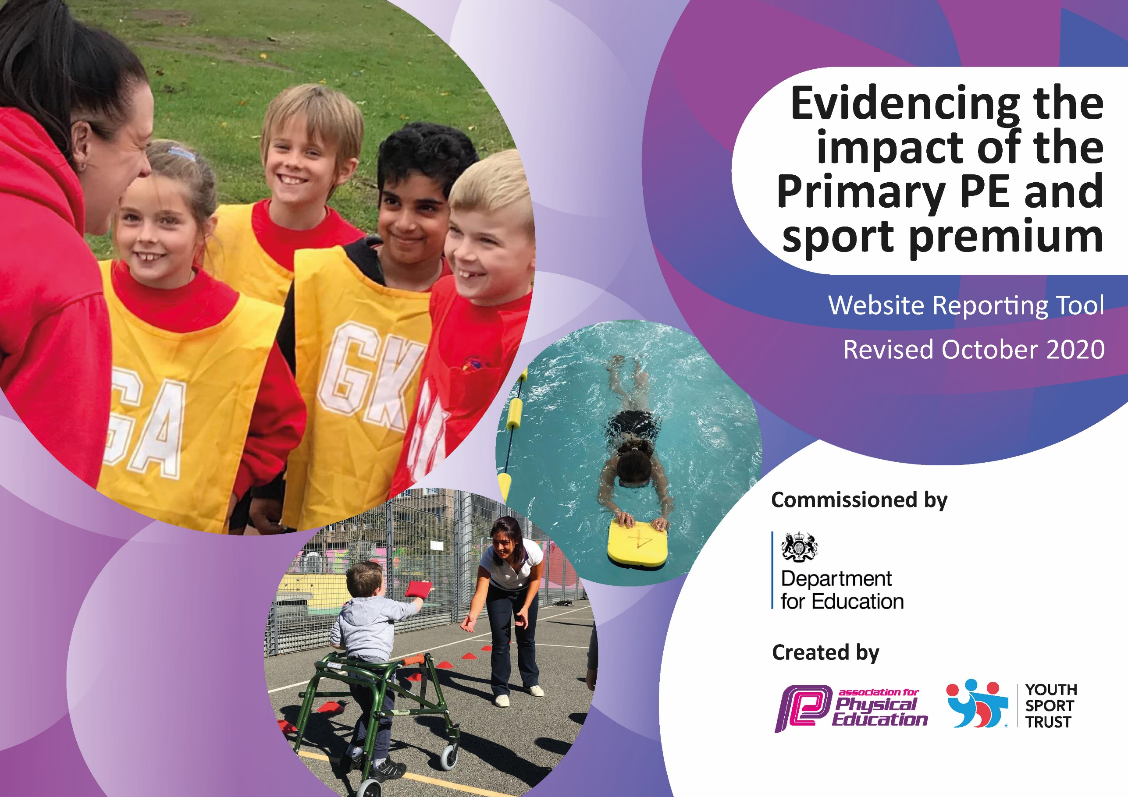

Key achievements for Swainswick Primary to July 2020: | Areas for further improvement and baseline evidence of need:
Online lessons/PE challenges by PE Lead :  https://www.youtube.com/channel/UCyUa6kpsByDS7fZtOy5SCFA/videos  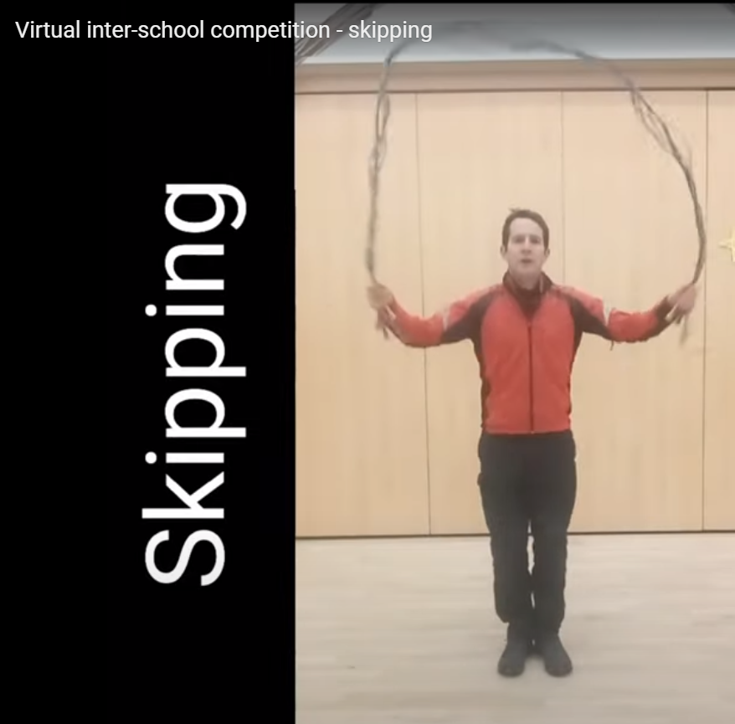  New playtime equipment for all bubbles.  New PE equipment so it can be quarantined between uses.  PE lead had time to reflect and contribute to wider PE community  https://issuu.com/healthyfutures/docs/healthy_futures_3_final_399730fa107fd0?fr=sMzFjMTI5MTA4Nzg  https://peumbrella.com/under-the-umbrella-with-brendan-rouse | Swimming stopped during Covid Pandemic  No inter-school fixtures  Large numbers of non-keyworker and non-venerable pupils had long periods of time not at school – although some were active some may not have been.

Did you carry forward an underspend from 2019-20 academic year into the current academic year? YES/NO * Delete as applicable

If YES you must complete the following section
If NO, the following section is not applicable to you

Academic Year: September 2020 to March 2021 | Total fund carried over: £ | Date Updated:
What Key indicator(s) are you going to focus on?  Key indicator 1: The engagement of all pupils in regular physical activity – Chief Medical Officers guidelines recommend that primary school pupils undertake at least 30 minutes of physical activity a day in school  Key indicator 2: The profile of PESSPA being raised across the school as a tool for whole school improvement  Key indicator 3: Increased confidence, knowledge and skills of all staff in teaching PE and sport  Key indicator 4: Broader experience of a range of sports and activities offered to all pupils  Key indicator 5: Increased participation in competitive sport |  |  |  | Total Carry Over Funding:
£
KI 1: 1,000 = 6%
KI 2: 9,377 = 58%
KI 3: 2,182 = 13%
KI 4: 0
KI 5: 0
Intent | Implementation |  | Impact
Your school focus should be clear how you want to impact on your pupils. | Make sure your actions to achieve are linked to your intentions: | Carry over funding allocated: | Evidence of impact: How can you measure the impact on your pupils; you may have focussed on the difference that PE, SS & PA have made to pupils re-engagement with school. What has changed? | Sustainability and suggested next steps and how does this link with the key indicators on which you are focussing this academic year?
Pupils to have better understanding and skills to motivate themselves to practice personal challenges.  Resilience and mental fitness in competitive games | Regular (daily) time to practice endurance or trickier skills.  PE lessons to include a game element where the pupils will experience success and not coming first. |  | Pupils able to run for longer.  Pupils to be able show progress on personal challenges: skipping, juggling  Pupils know that they will not win everytime, that failing can be part of the learning process. | All staff to be aware of tricky, trickier and trickiest progressions on a range of personal physical challenges.  Regular opportunities for pupils to experience being champions and challengers

Meeting national curriculum requirements for swimming and water safety.

What percentage of your current Year 6 cohort swim competently, confidently and proficiently over a distance of at least 25 metres?  N.B. Even though your pupils may swim in another year please report on their attainment on leaving primary school at the end of the summer term 2021. | 100%
What percentage of your current Year 6 cohort use a range of strokes effectively [for example, front crawl, backstroke and breaststroke]? | 100%
What percentage of your current Year 6 cohort perform safe self-rescue in different water-based situations? | 80%
Schools can choose to use the Primary PE and sport premium to provide additional provision for swimming but this must be for activity over and above the national curriculum requirements. Have you used it in this way? | No

Academic Year: 2020/21 | Total fund allocated: £16760 | Date Updated:
Key indicator 1: The engagement of all pupils in regular physical activity – Chief Medical Officers guidelines recommend that primary school pupils undertake at least 30 minutes of physical activity a day in school |  |  |  | Percentage of total allocation:
 |  |  |  | %
Intent | Implementation |  | Impact | £1000
What you want the pupils to know and be able to do | Make sure your actions to achieve are linked to your intentions: | Funding allocated: | What has changed?: | Sustainability and suggested next steps:
Staff have understanding of the impact on pupil’s learning and health of Daily Physical Activity.  Pupils have an understanding of the impact on learning and health of Daily Physical Activity – aware of heartbeat.  Regular brain/fitness breaks during curriculum time  Use large solar stopwatch in playground to time 5 minute run on side-grass | PE specialist to teach all classes the importance of physical activity.  All pupils to know how to do a warm up and to be able to show a ‘heartbeat puppet’.  Gonoodle and other activity websites used | Buying into BWMAT School Sports Partnership which includes support for Daily Physical Activity  £1,000 | Staff/Pupils familiar with activity websites: Gonoodle  BBC Supermovers  Joe Wicks Bodycoach  Online wake and shake includes all pupils and many parents, pre-schoolers.  All pupils can identify where their hearts are and demonstrate activities to get it beating faster and harder. | Find new websites: tiktok  Jumpstartjohnny  5-a-day
Key indicator 2: The profile of PESSPA being raised across the school as a tool for whole school improvement |  |  |  | Percentage of total allocation:
 |  |  |  | %
Intent | Implementation |  | Impact
What you want the pupils to know and be able to do | Make sure your actions to achieve are linked to your intentions: | Funding allocated: | What has changed?: | Sustainability and suggested next steps:
Primary Teacher with PE specialism to lead and promote physical activity, school sport and physical activity across the school.  Make sure Swainswick has all the equipment it needs for PE lessons and playtimes | Teacher employed one day a week to oversee all things PESSPA related  Staff, coaches, Lunchtime supervisors and pupils identify what equipment is needed: stilts,  pogo sticks,  skipping ropes,  speaker and battery,  bouncers  Tennis balls | £8710  £667 | PE has a member of teaching staff driving it forward ensuring that it keeps a very high profile | Rotate teacher leading PE to prevent gender/age sterotyping

Key indicator 3: Increased confidence, knowledge and skills of all staff in teaching PE and sport |  |  |  | Percentage of total allocation:
 |  |  |  | %
Intent | Implementation |  | Impact
What you want the pupils to know and be able to do | Make sure your actions to achieve are linked to your intentions: | Funding allocated: | What has changed?: | Sustainability and suggested next steps:
Staff support PE Apprentice and receive continued professional development with their Swainswick pupils in the Swainswick setting with Swainswick equipment.  Rugby CPD | Chloe from Progressive sports to teach alongside classteachers for one afternoon a week for 4 terms.  Avon Rugby Club Development Coach: Andy, to lead tag-rugby sessions in preparation for a tag-rugby festival | £2032  £150 transport to festival | Staff have seen PE led by specialist PE coach with upto date knowledge.  Attend a festival  Better understanding of Fundamentals of Movement, now using skills learnt in PE lessons. | Chloe teaches a different part of the PE Curriculum.  Primary Sports Coordinator to observe teachers leading their PE lessons to check and support understanding and delivery.  Other staff to attend coaching courses.
Key indicator 4: Broader experience of a range of sports and activities offered to all pupils |  |  |  | Percentage of total allocation:
 |  |  |  | %
Intent | Implementation |  | Impact
What you want the pupils to know and be able to do | Make sure your actions to achieve are linked to your intentions: | Funding allocated | What has changed?: | Sustainability and suggested next steps:
Take part in wider range of sport and physical activity | Virtual sportsday bonus event.  We filmed Yr 6 who were in school doing a range of skills: stilt walking, scooters, skipping, dance, gym, parkour, football skills etc  We asked pupils at home to upload films of themselves doing a range of activities. |  | Pupils uploaded BMXng, dance, gym, walking, races, obstacle courses with various skills... | Real and virtual talent competitions where we can showcase range of skills.  If inspired invite external activity leaders to share their skills.

Key indicator 5: Increased participation in competitive sport |  |  |  | Percentage of total allocation:
 |  |  |  | %
Intent | Implementation |  | Impact
What you want the pupils to know and be able to do | Make sure your actions to achieve are linked to your intentions: | Funding allocated: | What has changed?: | Sustainability and suggested next steps:
Online intra-school and inter-school competitions.  Youth Sports Trust  WESPORT  B&NES School Sport Partnership  PH Sports | Videos sent home of:  Agility: Speed steps  Balance: Stork balance  Coordination: Skipping  Standing long jump  Throwing and catching | £0 | Some pupils have recorded how with practise they have improved their personal best scores.

Signed off by
Head Teacher:
Date:
Subject Leader:
Date:
Governor:
Date:

